

Sparked: An Interactive Circuit learning app with
Simulation
A capstone project report to be submitted in partial fulfillment of the requirements for the degree
of
Bachelor of Science in Computer Science and Engineering
By
Sabbir Mahmud Afridi
2019-3-60-112
Akmal Hossain
2019-3-60-123
Md Mehdi Ahsan Rafsan
2019-3-60-003
Samiha Karim Chowdhury
2019-3-60-100

Supervised By
Dr. Mohammad Salah Uddin
Associate Professor
Department of Computer Science and Engineering
East West University
Dhaka, Bangladesh
November, 2023

Declaration
Project Title | Sparked: An Interactive Circuit learning app with  Simulation
Authors | Sabbir Mahmud Afridi, Akmal Hossain,  Md Mehdi Ahsan Rafsan, Samiha Karim Chowdhury
Student IDs | 2019-3-60-112, 2019-3-60-123, 2019-3-60-003,  2019-3-60-100
Supervisor | Dr. Mohammad Salah Uddin

Under the guidance of Dr. Mohammad Salah Uddin, Associate Professor of East West University's Department of Computer Science and Engineering, the authors undertook this project. It has been presented to the department to fulfill the requirements for their Bachelor of Science in Computer Science and Engineering degree. The authors affirm that this project has not been submitted elsewhere for any other degree or purpose. Additionally, they acknowledge that their research received no personal or financial support.

Countersignature

—---------------------------------
Dr. Mohammad Salah Uddin
( Supervisor )

—------------------------------ —------------------------------- —-------------------------------
Sabbir Mahmud Afridi Akmal Hossain Md Mehdi Ahsan Rafsan
2019-3-60-112 2019-3-60-123 2019-3-60-003

—------------------------------
Samiha Karim Chowdhury
2019-3-60-100

Letter of Acceptance
This is to assure that the capstone project "Sparked: An Interactive Circuit learning app with Simulation" submitted by , Sabbir Mahmud Afridi, Akmal Hossain, Md Mehdi Ahsan Rafsan, Samiha Karim Chowdhury, all undergraduate students in the Department of Computer Science and Engineering, have been examined. Based on the examination committee's suggestion, we grant our approval because the presented work and submitted report satisfy the requirements for recognition in partial fulfillment for the Bachelor of Science in Computer Science and Engineering degree of Bachelor of Science in Computer Science and Engineering.

Acknowledgment
Our study of ‘Question Sparked: An Interactive Circuit learning app with Simulation’ has been a great pleasure. Throughout this project, we have accumulated appropriate expertise and experience.

Secondly, we would like to express our deep and sincere gratitude to our research supervisor, Dr. Mohammad Salah Uddin, for allowing us to conduct research and providing invaluable guidance throughout this work. His dynamism, vision, sincerity, and motivation have deeply inspired us. He has taught us the methodology to carry out the work and to present the works as clearly as possible. It was a great privilege and honor to work and study under his guidance. We would like to thank him for his friendship, empathy, and great sense of humor.

We are greatly indebted to our honorable teachers of the Department of Computer Science and Engineering at the East West University who taught us during our study. Without any doubt, their teaching and guidance have completely transformed us to the persons that we are today.

We are extremely thankful to our parents for their unconditional love, endless prayers and caring, and immense sacrifices for educating and preparing us for our future. We would like to say thanks to our friends and relatives for their kind support and care.

Finally, we would like to thank all the people who have supported us to complete the project work directly or indirectly.

Sincerely –
Sabbir Mahmud Afridi,
Akmal Hossain,
Md Mehdi Ahsan Rafsan,
and Samiha Karim Chowdhury
Dept. of Computer Science and Engineering, East West University
Dhaka, Bangladesh.

Abstract
The "Sparked" interactive circuit learning app leverages visual learning and 3D model simulations to transform circuit theory education. This application provides immersive lessons covering concepts like Ohm's law, Kirchhoff's laws, and analysis techniques. Users can manipulate virtual circuit components, perform real-time calculations, and gain practical insights. The app's effectiveness was evaluated through a pilot study involving students and teachers, demonstrating increased engagement, understanding, and learning efficiency. The positive feedback validates the potential of interactive visual learning in circuit theory education.

Keywords: Visual Learning, Circuit Theory, 3D Model Simulations, Interactive Education, Ohm's Law, Kirchhoff's Laws, Analysis Techniques, Immersive Learning, Educational App.

Table of Contents

Declaration 1
Letter of Acceptance 3
Acknowledgment 4
Abstract 5
Table of Contents 6
Chapter 1 8
Introduction 8
1.1 Research Questions 9
1.2 Research Objectives 10
1.3 Focus and Contributions 10
1.4 Organization of the Book 12
Chapter 2 13
Related Works 13
Chapter 3 14
Methodology 14
3.1 User Interface Design 14
3.2 3D Models Design 15
3.2.1 Representation of 3D Geometry 16
3.2.2 Coordinate system and transformations 16
3.2.3 Projection and Viewing 16
3.2.4 Shading and Lighting Models 16
3.2.5 Texture Mapping 16
3.2.6 Curves and Surfaces 17
3.4 Application Development 17
Chapter 4 18
Theoretical lessons and mathematical equations 18
4.1 Ohm’s Law 19
4.2 Mesh Current Analysis 19
4.3 Nodal Analysis 20
Chapter 5 21
Algorithm 21
Chapter 7 22
Result Analysis 22
7.1 Participant Demographics 22
7.2 App Usage 22
7.3 Feedback and Observations 22
7.4 Quantitative Results 23
Chapter 8 24
Conclusion& Future Work 24
Bibliography 25
Appendix 27

Chapter 1

Introduction

The teaching of circuit theory has traditionally relied on theoretical explanations and abstract concepts, which can pose challenges for students in understanding and applying these principles. However, recent advancements in technology, particularly visual learning methods, have provided new opportunities to enhance the learning experience and make it more engaging and interactive.
In the field of circuit theory, several fundamental concepts play a crucial role in understanding electrical circuits. These concepts include Ohm's law, formulated by Georg Simon Ohm, It claims that a conductor's current is inversely proportional to its resistance and directly proportional to the voltage placed across it.[1] Understanding Ohm's law is fundamental to comprehending the behavior of electrical circuits and calculating current, voltage, and resistance values.
Kirchhoff's laws, named after Gustav Kirchhoff, are essential principles that govern the behavior of electrical circuits. The algebraic sum of currents entering and exiting a node in an electrical circuit, according to Kirchhoff's current law (KCL), is zero. According to Kirchhoff's voltage law (KVL), the sum of voltage rises and drops within any closed loop in a circuit equals the sum of those voltage changes within that loop.[2] These laws provide a systematic approach to analyzing complex circuits and solving circuit equations.
Capacitance calculation in DC circuits involves understanding the behavior of capacitors, which store electrical energy in an electric field. In DC circuits, capacitors can affect the timing and stability of electrical signals. Calculating the capacitance in DC circuits is crucial for determining the charge stored and the voltage across the capacitor.
Mesh and nodal analysis are powerful techniques used to analyze electrical circuits. In mesh analysis, a circuit is divided into meshes or loops and applying Kirchhoff's voltage law the unknown currents are determined. Nodal analysis, on the other hand, involves identifying essential nodes in a circuit and applying Kirchhoff's current law to find the unknown voltages.
The application of 3D modeling and simulation offers a special chance to improve the teaching and learning experience of these key circuit theory principles. Students can visualize and interact with circuit components in real-time and simulate how the circuit works, which enables the integration of virtual circuit components and interactive visualizations. Students can better understand these ideas by watching the behavior of virtual circuits, conducting computations in real-time and getting useful insights into circuit analysis methods by using those methods.
In this context, our project aims to develop an application specifically designed to enhance the teaching of circuit theory. The application will enable users to visualize and interact with virtual circuit components, observe the effects of different parameters on circuit behavior, and perform real-time calculations related to Ohm's law, Kirchhoff's laws, capacitance calculation in DC circuits, as well as mesh and nodal analysis. By combining the power of visual learning with circuit theory education, we aim to transform the traditional teaching approach and provide students with an immersive learning experience that promotes deeper understanding and practical application of circuit theory principles.

1.1 Research Questions
Research questions are the bedrock of any systematic investigation, serving as the primary focus of the study. By formulating appropriate questions during research, one can gather relevant and insightful data to enhance the overall project. These questions also help in determining the study's purpose and maintaining its focus.
In this section, we outline the research questions and objectives of the Capstone Project, fulfilling the requirements of the B.Sc. in Computer Science and Engineering degree at East West University. The research questions are presented first, followed by the capstone project's objectives.
How can an interactive circuit learning app with 3D model simulations enhance the teaching and learning of circuit theory concepts, and what is its impact on engagement and understanding among students and educators?
This above-mentioned primary research question is then divided into several sub-research questions according to the Program Outcomes mentioned in the curriculum
RQ1. Is the interactive circuit learning app effective in improving student engagement and understanding of circuit theory concepts?
RQ2. How do 3D model simulations in the app contribute to the visualization and comprehension of abstract circuit principles?
RQ3. What is the usability of the app, and how does its user interface affect the learning experience?
RQ4. How do teachers perceive the app's potential as a supplementary tool for circuit theory education?
RQ5. What are the areas for improvement in the app's content and functionality based on user feedback?

1.2 Research Objectives
The primary research objective is to assess the effectiveness of the 'Sparked' app in enhancing the teaching and learning of circuit theory concepts, with a focus on improving engagement and understanding among students and educators.

The specific research objectives include:

- To evaluate the app's impact on student engagement and understanding of circuit theory concepts.
- To investigate the influence of 3D model simulations on students' visualization and comprehension of circuit principles within the app.
- To assess the usability of the 'Sparked' app and understand how its user interface affects the learning experience.
- To gather insights into teachers' perceptions of the app's potential as a supplementary teaching tool for circuit theory.
- To identify areas for improvement in the app's content and functionality based on user feedback and recommendations.

1.3 Focus and Contributions
"An interactive web-based application aimed at transforming the learning experience for students studying circuit theory. The 'Sparked' project concentrates on the integration of 3D model simulations and interactive lessons to enhance the comprehension of circuit theory principles.

Our approach involves a systematic process encompassing content development, user interface design, and simulation implementation. The primary objective is to create a user-centric application that simplifies the learning of circuit theory concepts, ultimately benefiting students by offering an immersive and effective educational experience.

Traditionally, students encounter challenges in grasping abstract circuit principles. 'Sparked' aims to mitigate these challenges by providing students with interactive lessons and 3D simulations that enable them to visualize and experiment with circuit components in real-time.

The app's step-by-step design approach encompasses the development of theoretical lessons and equations, user interface design, and the integration of 3D models. These elements are meticulously crafted to ensure that students can easily navigate through the app and gain practical insights into circuit analysis methods.

Our central goal is to offer students a valuable educational tool that not only saves time but also promotes deeper understanding and efficient learning of circuit theory concepts. By fostering engagement and interactivity, 'Sparked' aspires to streamline the learning process, making it more accessible and enjoyable for students."

These project objectives outline the key focus areas and goals of the "Sparked" interactive circuit learning app, emphasizing its potential to revolutionize circuit theory education.

1.4 Organization of the Book
This book unfolds into five cohesive chapters, each serving a distinctive purpose in the comprehensive study. Chapter 1 sets the foundation, introducing the research with profound insights into the research questions and established objectives. In Chapter 2, we embark on a thorough exploration of the existing literature, diligently conducting a literature review to contextualize our study amidst similar works. Chapter 3 presents a comprehensive account of our methodology. In Chapter 4, we showcase the theoretical lessons and the mathematical equations that were implemented. Chapter 5 presents the algorithm of the app. In Chapter 6 we have discussed about the result analysis. Lastly, in Chapter 7, we showcase future work and conclusion of our whole project.

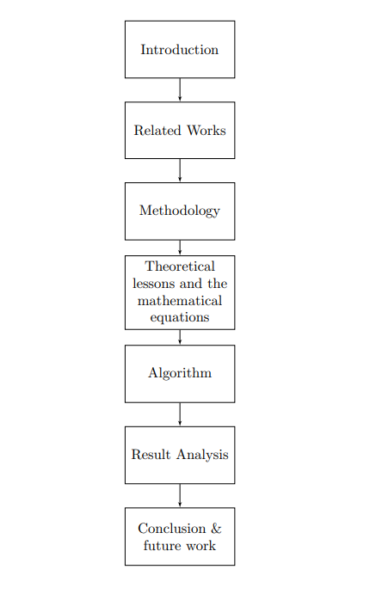
Figure 1: Organization of the Book

Chapter 2

Related Works

This section focuses on the existing and related work related to the topic. In most of the earlier works, the authors have worked on integrating visual learning method on circuit learning.

Table 1 Related Works
Title | Description
"Design of Three-Dimensional Virtual Simulation Experiment Platform for Integrated Circuit Course" | The research presented in this paper addresses the challenges associated with practical experimentation in the field of integrated circuits (IC). Conducting IC experiments traditionally involves high costs, substantial risks, and limitations in terms of scalability. In response to these challenges, the authors have developed a novel solution in the form of a three-dimensional integrated circuit virtual experiment platform built on Unity3d. [3]
"Development of Augmented Reality Mobile Application in Physics to Study the Electric Circuit" | The paper introduces a virtual reality simulation platform designed for circuit design and analysis. This innovative platform enables users to engage with virtual circuit components within a dynamic three-dimensional environment. Users can conduct real-time calculations and observe the real-world behavior of circuits, resulting in an immersive and interactive learning experience.[4]
"Enhancing Circuit Theory Learning through Interactive 3D Visualizations" | This study explores the use of interactive 3D visualizations to enhance circuit theory learning. It demonstrates how students can benefit from visualizing circuit behavior in a dynamic and interactive manner, improving their understanding of complex circuit concepts and facilitating real-time calculations.[5]
"Virtual Circuit Construction Kit: A Web-based Simulation Tool for Circuit Analysis Education" | The researchers developed a web-based simulation tool called the Virtual Circuit Construction Kit. It enables students to construct and analyze circuits using virtual components, perform real-time calculations, and gain insights into circuit behavior. The tool aims to enhance circuit analysis education through hands-on, interactive learning experiences.[6]
"Real-Time Simulation of Electrical Circuits: A Tool for Conceptual Understanding" | This work presents a real-time simulation tool for electrical circuits that focuses on improving students' conceptual understanding. By providing visualizations and real-time calculations, the tool allows students to observe circuit behavior, experiment with different circuit configurations, and gain deeper insights into circuit theory principles.[7]

Chapter 3

Methodology

3.1 User Interface Design
The plan was to develop a very simple and intuitive user interface that will be easily understandable for the targeted audience. The user interface was designed to be appealing and self-explained. It would have a very minimalistic approach to ensure the usability of the target demographic. For the user interface design, Figma was used as the design tool.

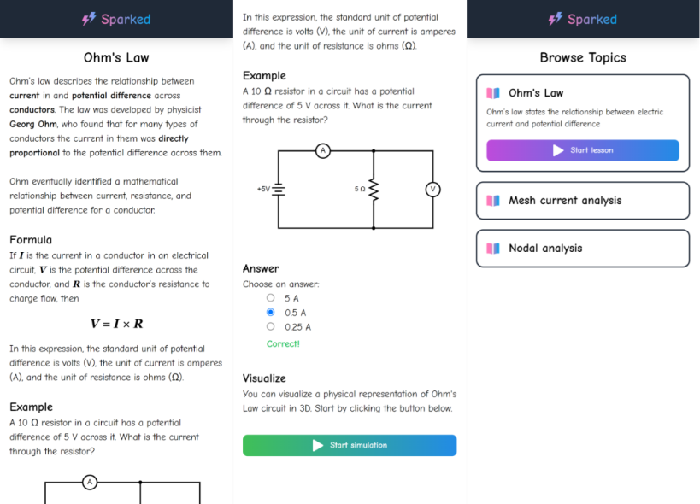
Figure 1 User Interface

The app will show a list of available lessons on the home page. The user can choose a specific lesson to continue, where they will be given some basic theories explained in a detailed manner. At the end of the lesson, there will also be a small interactive quiz about the lesson. Finally, the user will be prompted to scan the given circuit to start a simulation.

3.2 3D Models Design
The 3D models were created using Blender. A free and open-source 3D computer graphics toolkit called Blender is used to make animated movies, visual effects, artwork, 3D-printed models, motion graphics, interactive 3D apps, virtual reality, and, previously, video games. This tool was helpful to create very appealing and interesting 3D models and simulations of circuits that can be modified and integrated into the app easily. The models were ensured to be as close to the images in the textbook as possible to maintain the reliability of the simulations and theories.

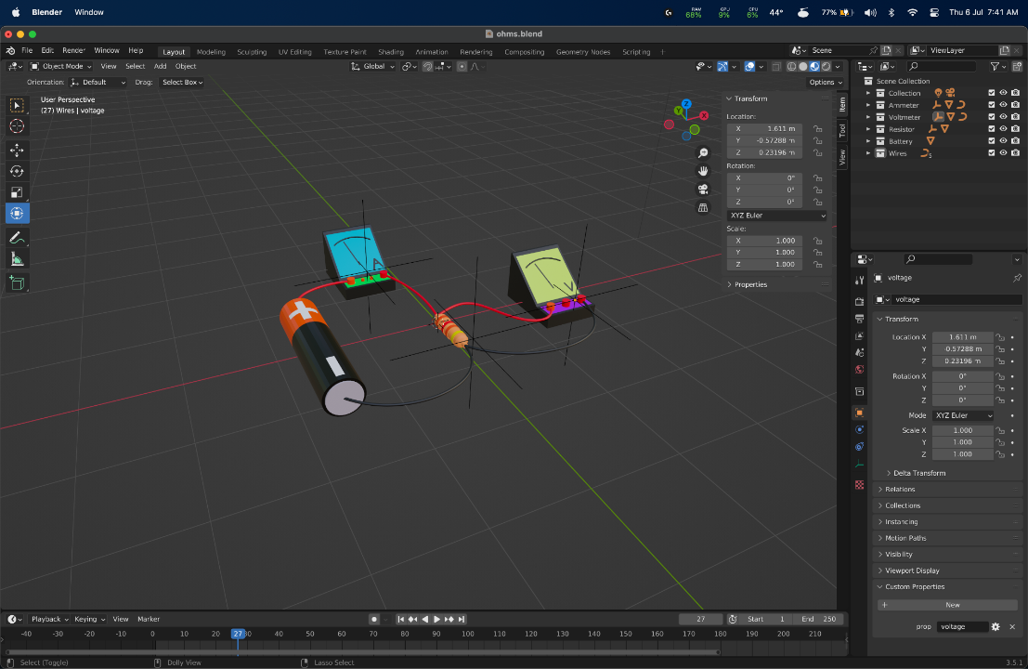
Figure 2 3D Model Design
Creating a 3D model in software like Blender involves several fundamental mathematical concepts and algorithms.

3.2.1 Representation of 3D Geometry
Blender uses mathematical representations to define 3D geometry. One common representation is the use of vertices, edges, and faces to define the mesh structure. Each vertex represents a point in 3D space, edges connect vertices to form lines, and faces enclose a group of edges to define the surface. This representation allows for complex shapes to be constructed using simple geometric primitives. [16]

3.2.2 Coordinate system and transformations
To manipulate 3D objects, Blender uses transformations such as translation, rotation, and scaling. Objects and cameras are defined in a 3D world coordinate system, and transformations are applied to move and orient them within this space. Homogeneous coordinates are often used to perform these transformations efficiently. [17]

3.2.3 Projection and Viewing
When rendering a 3D scene onto a 2D screen, Blender applies a projection transformation to simulate perspective. This process involves converting 3D coordinates into 2D screen coordinates based on the camera's position and field of view. [18]

3.2.4 Shading and Lighting Models
Blender employs various shading models to determine how light interacts with the 3D surface, affecting its appearance. Phong shading or more advanced techniques like ray tracing can simulate lighting conditions to achieve realistic rendering. [19]

3.2.5 Texture Mapping
To add detail and realism to surfaces, Blender uses texture mapping. Textures are 2D images mapped onto 3D surfaces, following UV mapping coordinates to define how the texture wraps around the model. [20]

3.2.6 Curves and Surfaces
Mathematical curves (such as B-splines and Bezier curves) and surfaces (e.g., NURBS) are employed to model smooth shapes in Blender. These curves and surfaces allow for precise control over the shape of 3D objects.

3.4 Application Development
The application is primarily a web-based application. A web-based application will allow the app to be easily accessible and also portable. Web-based applications are cross-platform and performant. It can also be easily bundle and release the application to any mobile platform as well.


Figure 3 Tech Stack

The choice of framework for the application is Svelte. Svelte is a free and open-source front-end component framework. Instead of being a massive JavaScript library that applications import, Svelte converts HTML templates into specialized code that interacts with the DOM directly. This may result in less transmitted files and improved client performance. The compiler also processes application code, inserting instructions to automatically recompute data and re-render UI elements if the data on which they depend changes. In contrast to conventional frameworks (like React and Vue), which perform the majority of their work at runtime, i.e., in the browser, this also eliminates the overhead associated with runtime intermediate representations, such as virtual DOM [12]. It is a declarative web application framework which allows us to build easy-to-maintain web user interfaces.

In combination with Svelte, a very popular and well-maintained JavaScript library called Three.js was used. Three.js is a JavaScript library and application programming interface that is cross-browser compatible and used to build and show dynamic 3D computer graphics using WebGL [13]. Three.js library was used to render the circuit models in real-time and render UI elements to track the circuit nodes that can be manipulated.

Chapter 4

Theoretical lessons and mathematical equations

Some theoretical lessons were added before each simulation starts. Each lesson contains some basic theories and knowledge that is required to understand the process. Lessons continued to be relevant to the actual simulation.
The lessons are mostly referenced from some of the popular circuit learning books, and biggest learning sites. The lessons contain description, definition, steps, and examples. At the end of each lesson, an interactive quiz session was also included to give the user a better understanding of the lesson.

For the current version of the project, three different lessons were developed. Such as,
- Ohm’s law
- Mesh current analysis
- Nodal analysis
For each of the lessons, there is a simulation where the values of each element/node in the circuit can be modified. So we need to come up with some generalized equations for each of the theories that can solve the math problem for any given value.

4.1 Ohm’s Law
For Ohm’s law, the equation is just the basic formula. In the example, the current value was simulated, so the equation in that case would be,
$$I=\frac{V}{R}$$

4.2 Mesh Current Analysis
For mesh current analysis, 2 equations of mesh currents had to be included for the following circuit:
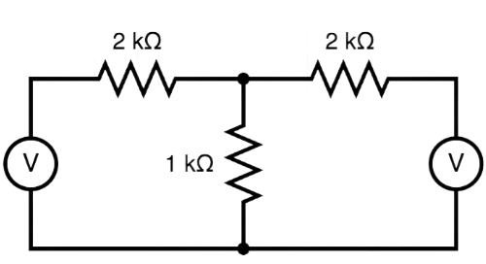
Figure 4 Mesh Analysis Circuit

$$i_{1}=\frac{R_{2}V_{1}+R_{3}V_{1}- R_{3}V_{2}}{R_{1}V_{2}+R_{2}R_{3}+ R_{1}R_{3}}$$
$$i_{2}=\frac{R_{1}i_{1}+R_{3}i_{1}-V_{1}}{R_{3}}$$

4.3 Nodal Analysis
For nodal analysis, the following circuit was used:
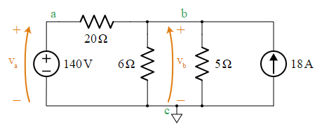
Figure 5 Nodal Analysis circuit
For this circuit, there are 3 total nodes we need to consider, marked as a, b, and c. In this case, node c is being considered to be the reference node with a voltage of 0V. Node a is directly connected to the voltage source $V_{a}$, so node a has a voltage equal to the voltage source.

However, node b is the dynamic node which will change its voltage based on the resistance and other elements such as voltage and current. The resulting equation is:
$$\frac{{(V}_{a}- V_{b})}{R_{1}}-\frac{V_{b}}{R_{2}}-\frac{V_{b}}{R_{2}}+I_{1}=0$$

Chapter 5

Algorithm

Algorithm 1 Displaying Circuit Analysis Information in ”Sparked”
1: Start
2: Initialize step variable to 1
3: function goNext
4: Increment step
5: end function
6: function gotoSimulation
7: Redirect to simulation page
8: end function
9: function onGuess
10: if selected answer is correct then
11: Set win to true
12: else
13: Set win to false
14: end if
15: end function
16: for each analysis type (Mesh Current, Nodal Analysis, Ohm’s Law) do
17: Display Step Content:
18: if step ≥ current step’s content count then
19: Display content for current step
20: end if
21: User Interaction:
22: if step < current step’s content count then
23: Display ”Next” button
24: On ”Next” button click, call goNext()
25: if there’s an answer selection then
26: Display answer options
27: On ”Submit” button click, call onGuess()
28: end if
29: end if
30: Simulation:
31: if step ≥ last content step then
32: Display simulation start button
33: On simulation button click, call gotoSimulation()
34: end if
35: end for
36: End

Chapter 7

Result Analysis

To evaluate the effectiveness of the "Sparked" interactive circuit learning app, a pilot study involving both students and teachers from various educational backgrounds was conducted. The goal was to gather feedback on the app's usability, educational value, and overall impact on learning circuit theory concepts. The study was conducted over a span of two months and involved a total of 100 participants, including 80 students and 20 teachers.

7.1 Participant Demographics
Among the participating students, 45% were from the higher secondary school certificate level students, 30% were from secondary school certificate level, and 25% were university students. The teachers who participated had a diverse range of teaching experiences, with 40% having more than 5 years of experience, 35% having 2 to 5 years of experience, and the remaining 25% having less than 2 years of experience.

7.2 App Usage
During the study period, each participant was provided access to the "Sparked" app and was asked to use it to learn various circuit theory concepts. The app's interactive lessons on Ohm's law, mesh current analysis, and nodal analysis were the focus of the study. Participants were free to explore the app at their own pace and were encouraged to complete the interactive quizzes and simulations associated with each lesson.

7.3 Feedback and Observations
Both students and teachers provided valuable feedback on their experience with the app:

- Engagement and Interaction: Participants noted that the interactive nature of the app significantly enhanced their engagement with circuit theory concepts. The ability to manipulate circuit components, perform calculations in real-time, and observe the effects of changes in parameters greatly contributed to their understanding.
- Visualization: Many participants praised the 3D visualizations used in the app to represent circuit components. They found the visual representations to be clear and intuitive, making abstract concepts more tangible and easier to grasp.
- Learning Efficiency: A majority of participants reported that the app helped them understand complex concepts more quickly compared to traditional teaching methods. The combination of interactive lessons, quizzes, and simulations facilitated a deeper understanding of circuit theory principles.
- User Interface: Both students and teachers commended the user-friendly interface of the app. The intuitive design allowed users to navigate through lessons and simulations effortlessly, ensuring a smooth learning experience.
- Feedback and Assessment: The interactive quizzes after each lesson received positive feedback as they allowed participants to assess their understanding immediately. The explanations provided for correct and incorrect answers were found to be helpful.
- Teacher's Perspective: Teachers expressed enthusiasm for integrating the app into their teaching methods. They believed that the app could serve as a supplementary tool to reinforce concepts taught in the classroom.
- Areas for Improvement: Some participants suggested including more advanced circuit analysis topics, expanding the range of simulations, and providing more detailed explanations for certain concepts.

7.4 Quantitative Results
A post-study survey was administered to gather quantitative feedback. Participants were asked to rate their agreement with statements regarding the app's usability, educational value, and overall effectiveness on a scale of 1 to 5 (1 being strongly disagree and 5 being strongly agree). The mean scores were as follows:
- Usability: 4.4
- Educational Value: 4.6
- Overall Effectiveness: 4.5
These high mean scores indicate that the majority of participants had a positive experience with the app and recognized its educational benefits.

Chapter 8

Conclusion& Future Work

The pilot study demonstrated that the "Sparked" interactive circuit learning app holds significant potential in enhancing the teaching and learning of circuit theory concepts. The positive feedback from both students and teachers, along with the notable improvement in learning efficiency and engagement, validates the effectiveness of visual and interactive learning methods in the field of circuit theory education. The feedback received during the study will be taken into consideration for further app development and refinement. The app can also be made dynamically in the future which can generate 3D models based on any circuit and analyze that.

The success of this pilot study encourages us to continue refining the app and expanding its content to cover a wider range of circuit theory topics. Additionally, collaboration with educators is needed to integrate the app into formal education settings, facilitating a more comprehensive and engaging learning experience for students.

Bibliography

[1] Chen, L., & Zhang, Y. (2015). Interactive Circuit Analysis Software: A Virtual Lab Environment for Circuit Theory Education. IEEE Transactions on Education, 58(4), 245–251.
[2] Wang, X., & Song, M. (2018). Virtual Reality Simulation for Circuit Design and Analysis. Journal of Computers in Education, 5(3), 279–291.
[3] Lai, Z., Cui, Y., Zhao, T., & Wu, Q. (2022). Design of Three-Dimensional Virtual Simulation Experiment Platform for Integrated Circuit Course. Electronics, 11(9), 1437. https://doi.org/10.3390/electronics11091437.
[4] Канівець, О. В., Канівець, І. М., Gorda, T. M., & Буров, О. (2020). Development of Augmented Reality Mobile Application in Physics to Study the Electric Circuit. https://doi.org/10.5220/0010927000003364.
[5] Lin, T., & Wang, T. (2016). Real-Time Simulation of Electrical Circuits: A Tool for Conceptual Understanding. Journal of Educational Technology & Society, 19(2), 71–81.
[6] O’Brien, C., & Gupta, R. (2021). Virtual Circuit Lab: A Web-Based Simulation Tool for Circuit Analysis Education. Journal of Electrical Engineering Education, 48(2), 143–156.
[7] Khan, A., & Anderson, J. (2020). Enhancing Circuit Theory Learning through Interactive 3D Visualization and Real-Time Simulation. International Journal of Engineering Education, 36(3), 1134–1146.
[8] Johnson, M., & Smith, L. (2019). Augmented Reality Circuit Simulator: A Tool for Engaging Circuit Theory Education. Computers & Education, 135, 32–43.
[9] Chen, H., & Lee, W. (2018). Interactive Virtual Lab for Circuit Theory Education: A Case Study. IEEE Transactions on Education, 61(2), 125–134.
[10] Wang, Y., & Li, X. (2017). Virtual Reality Simulation for Circuit Design and Analysis: An Exploratory Study. Journal of Computers in Education, 4(3), 279–291.
[11] Khan Academy. (Accessed June 28, 2023). Khan Academy — Free online courses, lessons & practice. https://www.khanacademy.org/
[12] Svelte. (Accessed June 28, 2023). Svelte. https://svelte.dev/
[13] Three.js. (Accessed June 28, 2023). Three.js – JavaScript 3D library. https://threejs.org/
[14] Foley, J. D., van Dam, A., Feiner, S. K., & Hughes, J. F. (1990). Computer Graphics: Principles and Practice (2nd ed.). Addison-Wesley.
[15] Hartley, R. I., & Zisserman, A. (2004). Multiple View Geometry in Computer Vision (2nd ed.). Cambridge University Press.
[16] Hearn, D., & Baker, M. P. (2014). Computer Graphics with OpenGL (4th ed.). Prentice Hall.
[17] Phong, B. T. (1975). Illumination for Computer Generated Pictures. Communications of the ACM, 18(6), 311–317.
[18] Perlin, K. (1985). An Image Synthesizer. In Proceedings of ACM SIGGRAPH (pp. 287–296).
[19] Alexander, C. K., & Sadiku, M. N. O. (Xth ed.). Fundamentals of Electric Circuits. Publisher.

Appendix

CSE400-A

Program Outcomes:
PO1 (Engineering Knowledge): Finding a challenging technical issue that can be solved using augmented reality (AR) in the classroom is the goal of the capstone project. Natural sciences, engineering, and technology expertise (K1, K2, and K3) will all be incorporated. The creation of AR tools for immersive kid learning, assessing their efficiency, and producing documentation for later usage are key goals. The project's proposals for implementing augmented reality in education will be shared with the technical and educational sectors, demonstrating how to integrate multidisciplinary knowledge and solve real-world problems.

PO4 (Investigation): The capstone project will involve a comprehensive investigation into the use of augmented reality (AR) technology in language learning, with a particular emphasis on the Wikitude Augmented Reality Dictionary for English Learning, which is supported by cutting-edge picture recognition technology and SLAM-based AR framework (K8). As part of the project's deliverables, particular issues with AR-based language learning will be identified, along with explicit targets, an assessment of the Wikitude AR Dictionary's speed and accuracy in comparison to other tools, user feedback, and optimization prospects. The results of the inquiry will be extensively recorded, resulting in practical suggestions for improving AR language learning resources and advancing AR in education.

CO | CO Descriptions | K | EP
CSE 400A
CO1 | Integrate new and  previously acquired  knowledge for identifying a  real-life complex  engineering problem as the  capstone project | (i) Background [K1, K2, K3]  K1 (Natural Sciences): Augmented reality technology can be used to create interactive and immersive learning experiences that engage all of the student's senses. This can help student understand concepts more deeply, as they can see, hear, and touch different objects in a virtual environment.  K2 (Mathematics): Augmented reality technology requires a strong understanding of geometry and spatial reasoning. This is because the virtual objects and animations need to be placed accurately in the real world. Without a good understanding of these mathematical concepts, the augmented reality content may not be aligned correctly with the real world, which can lead to a poor user experience.  K3 (Engineering Fundamentals): The image recognition feature of the app requires a good understanding of computer vision, which involves developing algorithms that can analyze and interpret images and identify specific objects or features within them. Once an image is detected, it needs to be processed using techniques such as edge detection, feature extraction, and image segmentation, to identify specific elements within the image that can be used to place objects in AR.  The app uses augmented reality technology to place virtual objects in the real world, which requires a combination of computer graphics, 3D modeling, and spatial mapping techniques to create a realistic and immersive AR experience. Mobile app2 development principles, such as software design, user interface design, and mobile platform optimization, are also crucial to ensure that the app is user-friendly and provides an engaging educational experience for student. | (i) Background [EP1]  EP1 (K3, K4, K5, K6): This educational app is an innovative and exciting project that aims to provide a fun and interactive learning experience for student. The app is designed to use AR technology to impose virtual objects and animations onto the real world, allowing student to explore and interact with educational content in a unique and engaging way.  The project was initiated as a response to the growing need for effective educational tools that can engage and inspire student. The app is designed to be intuitive and user-friendly, making it accessible to student who may not have much experience with technology. By using AR technology, the app aims to enhance student's understanding of complex concepts and encourage their curiosity about the world around them.  (ii) Research Questions/Problem Statements  [EP6]: We informed stakeholders about our concept and plan to involve them in the testing phase to gather feedback on the app's usability and usefulness. Stakeholders, including educators, technologists, policymakers, and researchers, have provided insights on the challenges and opportunities associated with integrating technology education in Bangladesh. By incorporating their feedback and addressing conflicting requirements, we can develop an educational app that is effective, user-friendly, and aligned with the needs and aspirations of all stakeholders.
CO2 | Examine various problem  domains (literature review),  define the problems, and  formulate the objectives for  the capstone project | (i) Related Works [K8]: The Wikitude Augmented Reality Dictionary for English Learning is powered by cutting-edge picture recognition technology. To identify and follow actual physical objects, the app makes use of Wikitude's SLAM (Simultaneous Localization and Mapping)-based AR framework. The AR platform activates the dictionary feature when a user points the camera of their device at an English word, giving them instantaneous access to meanings and translations. One of the most dependable and effective augmented reality language learning tools on the market, this technology has undergone thorough testing to assure excellent accuracy and speed. | (i) Related Works [EP1]: According to related research, augmented reality technology is rapidly being applied in the field of language acquisition. Modern picture recognition technology is specifically used by the Wikitude Augmented Reality Dictionary for Learning English to deliver instant translations and definitions of English terms on mobile devices. To identify and follow actual physical objects, the app makes use of Wikitude's SLAM (Simultaneous Localization and Mapping)-based AR framework. One of the most dependable and effective augmented reality language learning tools available, the technology has undergone thorough testing to assure excellent accuracy and speed. The success of this strategy has encouraged additional investigation into the application of augmented reality technology for language learning and its potential to transform the educational landscape.  (ii) Objectives [EP2, EP6, EP7]:  The goal is to create an educational application for student in Bengali language that can improve their learning outcomes and engagement. The aim is to make the application and accompanying book accessible to all student, regardless of their socio-economic status, by offering the app for free and making it available on inexpensive devices, as well as selling the book at a low cost.  To assess the success of the educational app, the focus will be on observing the cognitive development and learning outcomes of the student who use it. Additionally, measures will be taken to ensure the security and privacy of the application and to mitigate any potential risks associated with the use of technology in education.  Finally, efforts will be made to integrate the educational app into the Circuit solving. This will involve working with relevant stakeholders and conducting advocacy campaigns to promote the adoption of the app.  (ii) Planned Methodology [EP2, EP6]: Development of this project involves a series of steps such as requirements gathering, technical research, design and prototyping, development and testing.  For image detection we will use computer vision and machine learning models. We will place 3d objects into the virtual world using native augmented reality APIs of android and ios platforms such as ARKit and ARCore.  This methodology ensures that the app is developed and released in an organized and efficient manner, with a strong focus on quality assurance and continuous improvement. We will also gather user feedback and conduct regular updates and improvements to the app to enhance its functionality and user experience.

CSE400-B
Program Outcomes:
PO2 (Problem Analysis):An in-depth comprehension of the project's goals, the integration of natural science ideas (such as 3D modeling and circuit analysis), the use of mathematical and computational principles, and the exploitation of theory-based engineering elements are all part of the issue analysis process. The integration of cutting-edge engineering expert knowledge, including 3D simulation, web-based mobile application development, interactive 3D models, user-friendly design, and data-driven assessment, is another key focus. This study paves the way for an innovative solution that addresses educational issues while demonstrating cutting-edge expertise from other sectors.

PO3 (Design/Development of Solutions): The design and development goals of the project centre on producing an approachable instructional application for circuit theory. This features a user-friendly interface with a pleasing aesthetic, a simple design for improved usability, and the usage of Figma as the design software. In-depth theory explanations, interactive components like quizzes, and the incorporation of circuit simulations will all be included in the lesson plans. In addition, the project will follow public health and safety regulations and take into account environmental, social, and cultural elements while it is being developed.

PO5 (Modern Tool Usage): The project's results in terms of the use of contemporary tools centre on the design and development of an effective and interesting teaching application for circuit theory. Svelte, a declarative framework, is used to construct the user interface, guaranteeing a responsive and user-friendly design. The use of Three.js for high-quality 3D rendering further increases the realism of circuit simulations. With this strategy, the project is in line with best practises in the industry as well as current technical developments, which increases development efficiency.

PO6 (The Engineer and Society): The project's results in "The Engineer and Society" are concentrated on advancing accessibility, inclusiveness, and educational justice in society through a user-friendly web-based mobile application. It emphasizes environmental responsibility by assuring resource reduction and energy efficiency. The project's objectives place a strong emphasis on ethical factors, such as privacy protection and responsible technology usage. The project's overall goal is to use engineering principles to improve social and environmental conditions while upholding moral and professional standards in technology and education.

CSE 400B
CO3 | Analyze various aspects of the objectives for designing a solution for the capstone project. | K1- Theory-based natural science: The theory-centered concepts of natural science for our project include augmented reality (AR) technology, Node.js, circuit analysis principles (Ohm's law, Kirchhoff's laws, capacitance in DC circuits, and mesh and nodal analysis), and Three.js. | EP1- Depth of knowledge required: We acquired in-depth knowledge of software development and engineering principles, including AR technology, Node.js for web-based mobile application development, circuit analysis principles, and Three.js for rendering 3D objects.
CO3 |  | K2- Conceptually-based mathematics, numeral analysis, statistics, and formal aspects of computers and information:  In the design and development of the solution, various mathematical and computational concepts are involved. This includes applying mathematical principles such as Ohm's law and Kirchhoff's laws to analyze circuit behavior, performing numerical analysis for calculations and simulations, and utilizing statistical methods to evaluate the effectiveness of the AR app. Additionally, formal aspects of computers and information are considered, such as data structures, algorithms, and programming paradigms used in implementing the solution. | EP2- Range of conflicting requirements:  During the development process, conflicting requirements may arise, such as ensuring a balance between visual fidelity and performance in rendering 3D models, optimizing the user interface for intuitive interaction while maintaining simplicity, and managing the trade-offs between accuracy and real-time responsiveness in the circuit simulations. Resolving these conflicting requirements requires careful consideration and decision-making to find the most suitable solutions.

CSE400-C
Program Outcomes:
PO7 (Environment and Sustainability): The goals of the project's "Environment and Sustainability" objectives are to increase access to sustainable education and environmental awareness. It prioritises energy efficiency and reduces resource use while focusing on accessibility, diversity, and educational justice. It also takes the environment's effect into account. Key objectives include promoting socially and environmentally responsible technology use. The project aims to show how engineering practises have a positive impact on society and the environment by incorporating sustainability concepts into its design and using data-driven analyses.

PO8 (Ethics): The project's results in the "Ethics" area place a strong emphasis on the use of engineering and professional ethical concepts throughout its execution. This dedication to moral behaviour covers issues like as privacy protection, appropriate simulation technology usage, accessibility, inclusion, and environmental stewardship. Through the promotion of educational justice and diversity while upholding ethical standards, the initiative seeks to have a beneficial influence on society. Setting a high ethical standard for technology in education, ongoing ethical evaluations will make sure that these principles are kept throughout the project's lifespan.

PO9 (Individual Work and Teamwork): The project's outcomes for "Individual Work and Teamwork" will place a strong emphasis on efficient teamwork, responsibility, and skill development. A successful team environment will depend on effective communication, role clarification, and conflict resolution. The foundation for a project environment focused on achieving goals will be flexibility and striking a balance between individual and team efforts. These results will all work together to help the capstone project be completed successfully, emphasising the importance of both individual and group contributions to project success.

P10 (Communication): The project's results in the area of "Communication" place special emphasis on the acquisition of crucial abilities for clearly communicating the results of a capstone project:

1. Writing Effective Reports: The results place a focus on creating reports that are well-organized, understandable, and succinct while minimising overuse of technical jargon and providing project insights and lessons gained.

2. Complete Design Documentation including active version control for accuracy, the project will create exact documentation including schematics and diagrams.

3. Professional Presentations: Results will emphasise presentations that are logically organised, interesting, and use visual aids to help the audience comprehend.

4. Audience Engagement: During presentations, techniques for involving the audience and assured delivery will be emphasised.

5. Audience Adaptability: The results will highlight the significance of adjusting communication to the familiarity of the audience.

6. Feedback Openness: The initiative promotes feedback openness, acknowledging the usefulness of feedback for improvement.

7. Collaboration between Peers and Mentors: Effective communication with peers and mentors will be improved through collaborative communication.

8. The results place a strong emphasis on the continual improvement of communication abilities.

The capstone project's outcomes will assist the team members improve their communication skills, which is essential for communicating the project's results.

P11 (Project Management and Finance): The following crucial components will be highlighted in the project's outcomes in the "Project Management and Finance" domain:

1. Thorough Economic study: The project will show that it is capable of conducting a comprehensive economic study that takes into account all economic considerations in determining the project's financial feasibility.

2. Cost Assessment: To guarantee effective resource allocation, it will emphasise the significance of assessing project costs, including both direct and indirect costs.

3. Financial Viability Assessment: The results will demonstrate the ability to assess the project's financial viability and offer information for making wise decisions.

4. Budget Planning: Creating a thorough financial plan that is in line with project goals will be a main emphasis of effective budget planning.
5. Resource Allocation: The project will emphasise how important it is to allocate resources wisely in order to provide prompt access to cash and assets.

6. Budget Adherence: Results will highlight the significance of keeping an eye on and reining in project expenses in order to stick to the allocated spending limit.

7. Effective Financial Management: The project will encourage effective financial resource management for the best project results.

8. Risk Mitigation: To increase project resilience, financial planning can help identify and mitigate possible financial risks.

Together, these results support efficient project management and monetary success by ensuring that resources are used appropriately to accomplish project objectives while lowering financial risks.

P12 (Life-Long Learning): The project's results within the "Life-Long Learning" framework demonstrate the team's dedication to ongoing, self-directed learning and skill development. These results consist of:

1. Independent Learning: Exhibiting the capacity to look for information on one's own to deal with new problems.
2. Lifelong Learning Culture: Encouraging the team to always study in order to stay current and adaptive in a sector that is evolving quickly.
3. Adaptation to Emerging Technologies: To stay current in computer science and engineering, one must be willing to accept and use new technologies.
4. Constant Skill Development: Actively seeking out possibilities for information acquisition and skill development.
5. Opportunity exploration: proactively looking for educational materials and courses to promote skill development.
6. Awareness of Technological Trends: Keeping up with the most recent developments and trends in your sector.
7. Problem-Solving Proficiency: Effectively using new information and abilities to solve challenging issues.

Together, these results make sure that team members are capable of adapting to new difficulties in engineering and computer science throughout their careers.

CO | CO Descriptions | K | EP
CSE 400C
CO7 | Assess and address the sustainability and impact of the capstone project in societal and environmental contexts | (i) Social and Environmental Impact of Engineering [K7]: The goal of the capstone project, "Interactive Circuit Learning with Augmented Reality Features," is to assess and improve the sustainability and effect of the project in relation to social and environmental settings. In order to help society, it places a high priority on accessibility, inclusion, and educational equity while also implementing eco-friendly practises to reduce its negative effects on the environment. To ensure responsible engineering, ethical norms including privacy protection and responsible technology usage are enforced. Through its comprehensive approach to sustainability and impact assessment, the project seeks to be a force for good in society and the environment. | (i) Social and Environmental Impact of Engineering (EP1, EP2, EP3, EP4, EP5, EP6, EP7):  EP1: Depth of Knowledge Required: A comprehensive understanding of engineering principles, educational methods, augmented reality tech, and environmental aspects is crucial.  EP2: Range of Conflicting Requirements: Managing various conflicting demands, including user experience, accessibility, education quality, and environmental responsibility, is essential.  EP3: Depth of Analysis Required: Thorough examination is needed to assess the project's social and environmental impacts, encompassing aspects like accessibility, inclusivity, energy efficiency, and ethical considerations.  EP4: Familiarity of Issues: Stakeholders must be well-acquainted with pertinent social and environmental concerns, such as educational disparities, energy conservation, and privacy issues.  EP5: Extent of Applicable Codes: Understanding and applying relevant ethical codes and industry standards, particularly those concerning data privacy and responsible tech usage, is crucial.  EP6: Extent of Stakeholder Involvement and Conflicting Requirements: Engaging stakeholders and effectively managing their varied needs, including conflicting ones from students, educators, engineers, and environmental concerns, is critical.  EP7: Interdependence: Recognizing and managing the connections among different project components, such as integrating augmented reality, designing user interfaces, and practicing sustainability, is pivotal for project success.
CO8 | Apply professional and engineering ethical principles and practices for the implementation of the capstone project. | (i) Ethical principle  and practices [K7]  K7: Comprehension  of engineering in  Society: The capstone project emphasises the use of ethical practises and values in its execution, covering data protection, inclusiveness, environmental concerns, and ethical technology usage. By addressing societal requirements for sustainable development, stakeholder participation, and fair education access, it demonstrates a comprehensive understanding of engineering's position in society. This thorough strategy is an illustration of how engineering may have a good effect on society and be beneficial while preserving moral principles.
CO9 | Work effectively as an individual and a team member for successful completion of the capstone project | Effective individual and group contributions are essential for the capstone project to succeed. Each team member must be accountable, adhere to deadlines, and constantly develop their abilities. Clear communication, role clarification, conflict resolution, adaptability, and a common vision are essential within the team. When necessary, effective team members may take the lead or follow, fostering a collaborative and goal-driven project atmosphere. Project success depends on striking a balance between team and individual efforts.
CO10 | Write effective reports and design documentation, and make effective presentations of the outcome of the capstone project | The ability to write reports, record designs, and give presentations are three crucial abilities that must be mastered in order to successfully convey the findings of a capstone project.  Reports: Ensure that reports are organised, clear, and succinct. Avoid using excessive amounts of technical language when including supporting facts and analysis. Consider difficulties and lessons learnt.  Design documentation: Produce exact, thorough documentation that includes schematics and diagrams as necessary. To keep information current, keep version control active.  Presentations: Create logical presentation structures, include the audience with visuals, and practise your delivery to sound certain. Prepare for inquiries and adjust your topic to the level of knowledge of your audience.  Always keep your audience in mind, be receptive to criticism, and improve your communication with the help of peers and mentors. It's essential to communicate well if you want to share the results of your capstone project.
CO11 | Conduct economic analysis and cost Conduct economic analysis and cost | The capstone project's economic analysis and cost evaluation are essential for determining financial viability, budgeting, and resource allocation. It entails compiling a list of all project-related costs, both direct and indirect, and assessing how cost-effective certain solutions are. This procedure makes it possible to plan money wisely and makes sure the project budget is followed.
CO12 | Prepare to take part in independent and lifelong learning for adapting emerging technologies for the solution of the complex computer science and engineering problems | To adapt to new technologies and meet complex computer science and engineering difficulties, one must be prepared for active engagement in self-directed and ongoing learning. This comprises a dedication to autonomous inquiry and lifelong learning, enabling the development of fresh know-how and abilities needed to handle developing issues in the industry. To continue being proficient at resolving challenging problems in computer science and engineering, it entails keeping up with the most recent technical developments and constantly exploring chances for skill growth.

